Chapter 11, Solution 50.

- 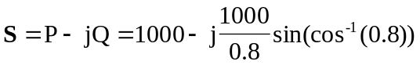
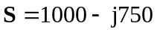

But, 

 